

SCHOOL OF ENGINEERING

|  |
| --- |
| Data Analytics Foundation – EN6001 |
|  |

Exercise

# Visualizations using Tableau

Enrollment Id Enrollment No.

Shambhavi Goswami AU19B1006

Bachelor of Technology

(2021-2022)

**Dashboard 1**

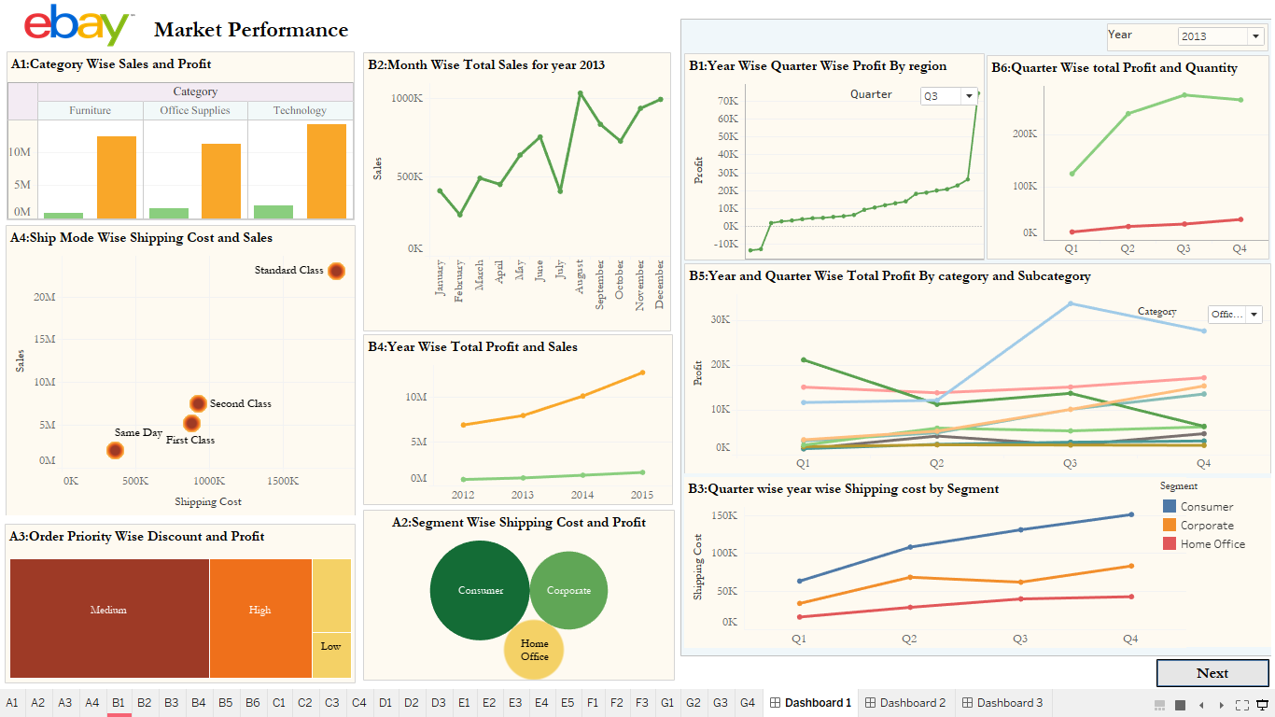

**Dashboard 2**

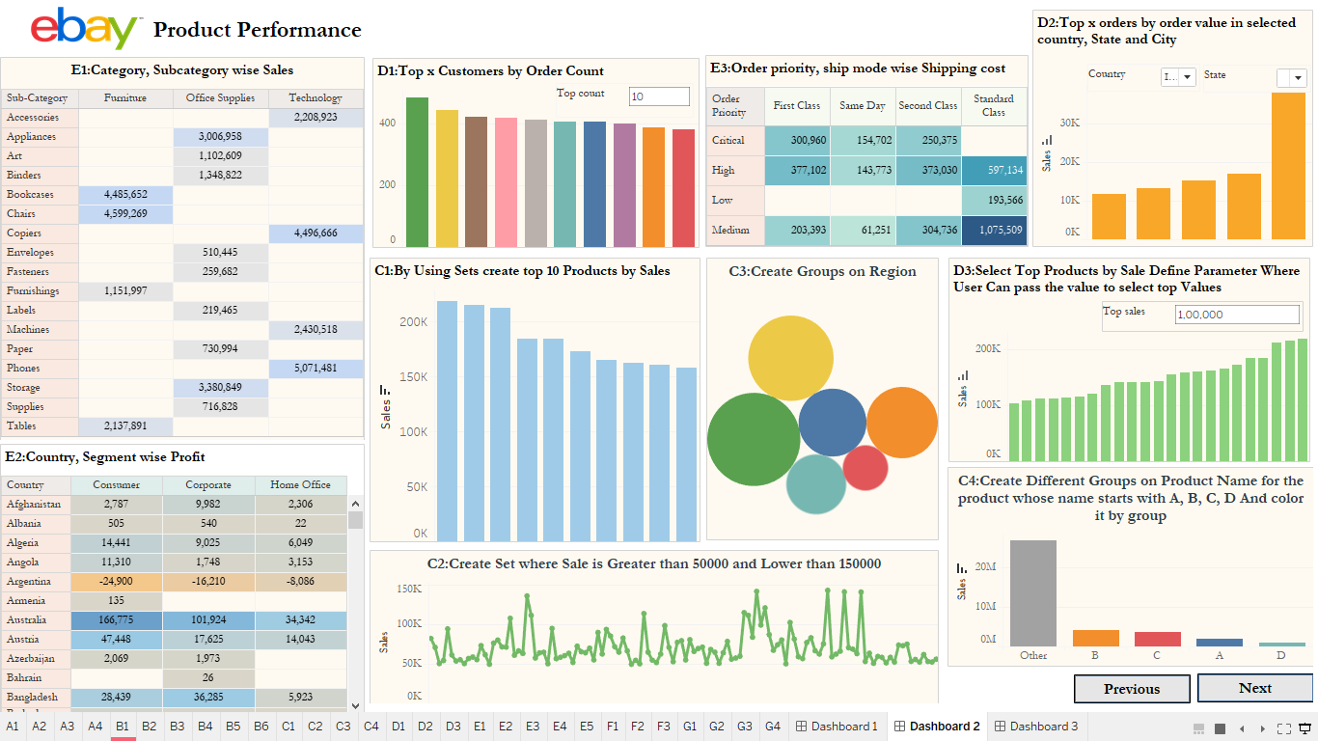

**Dashboard 3**

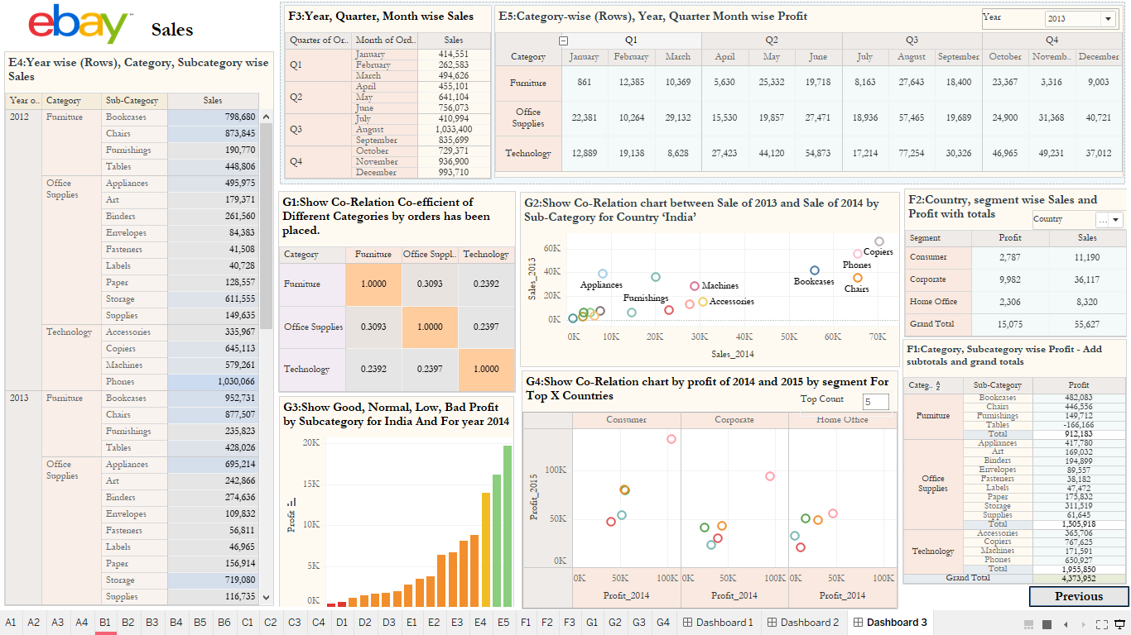

**Inference**

All the analytical questions are solved using different types of graph such as trend line chart, bar graph, density graph, matrix chart ,tabular chart, tree map and bubble chart. The visualization also includes the usage of calculated fields, filters, parameters, sets, groups and actions. In all the charts the details are provided in the tooltip for different measure values: profit, sales, shipping cost and quantity. Also some filters are set to combination of charts to show the change in graph by only a single filter selection. At the end, the charts are combined in three dashboards in different layout structures.